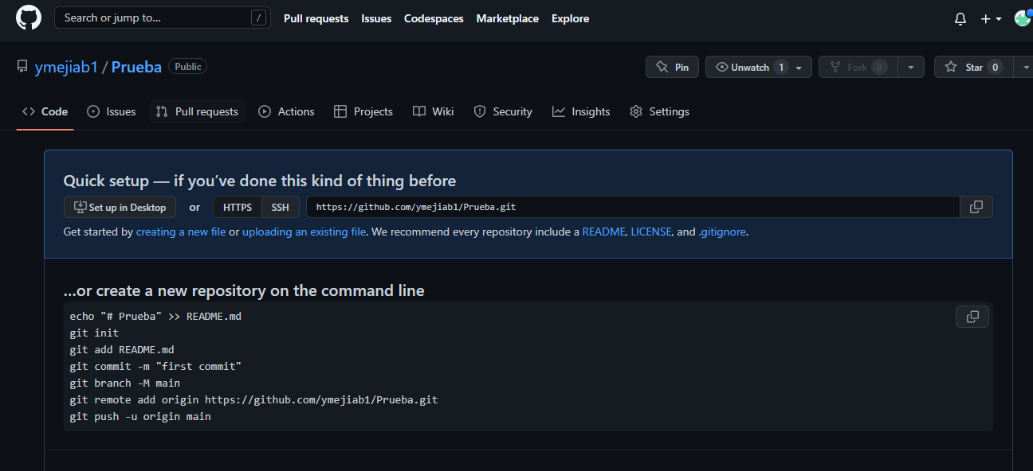

**…or create a new repository on the command line**

echo "# Prueba" >> README.md

git init

git add README.md

git commit -m "first commit"

git branch -M main

git remote add origin https://github.com/ymejiab1/Prueba.git

git push -u origin main

### or push an existing repository from the command line

git remote add origin https://github.com/ymejiab1/Prueba.git

git branch -M main

git push -u origin main

### …or import code from another repository

You can initialize this repository with code from a Subversion, Mercurial, or TFS project.